**Event Handling with Swing components**

**Example 1:**

**EventDemoo.java**

package com.domain.doubtpack;

import java.awt.*;

import java.awt.event.*;

import javax.swing.*;

class EventDemoo implements ActionListener

{

JLabel jlab;

EventDemoo()

{

// Create a new JFrame container.

JFrame jfrm = new JFrame("An Event Example");

// Specify FlowLayout for the layout manager.

jfrm.setLayout(new FlowLayout());

// Give the frame an initial size.

jfrm.setSize(220, 90);

// Terminate the program when the user closes the application.

jfrm.setDefaultCloseOperation(JFrame.EXIT_ON_CLOSE);

// Make two buttons.

JButton jbtnOk = new JButton("OK");

JButton jbtnCancel = new JButton("Cancel");

// Create a text-based label.

//JLabel jlab= new JLabel("Push a button.");

jlab = new JLabel("Push a button.");

// Add action listener for Ok button.

jbtnOk.addActionListener(this);

// Add action listener for Cancel button.

jbtnCancel.addActionListener(this);

// Add the buttons to the content pane.

jfrm.add(jbtnOk);

jfrm.add(jbtnCancel);

// Add the label to the content pane.

jfrm.add(jlab);

// Display the frame.

jfrm.setVisible(true);

}

public void actionPerformed(ActionEvent ae)

{

//store the name written in button that is clicked ,in variable s

String s = ae.getActionCommand();

if(s.equalsIgnoreCase("ok"))

jlab.setText("OK pressed.");

else if(s.equalsIgnoreCase("cancel"))

jlab.setText("Cancel pressed.");

}

public static void main(String args[])

{

new EventDemoo();

}

}

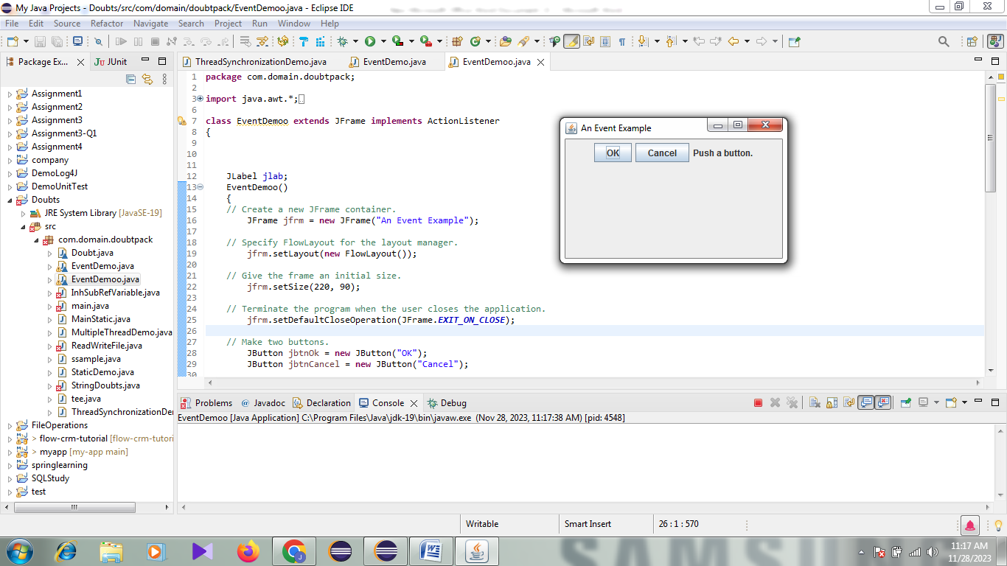 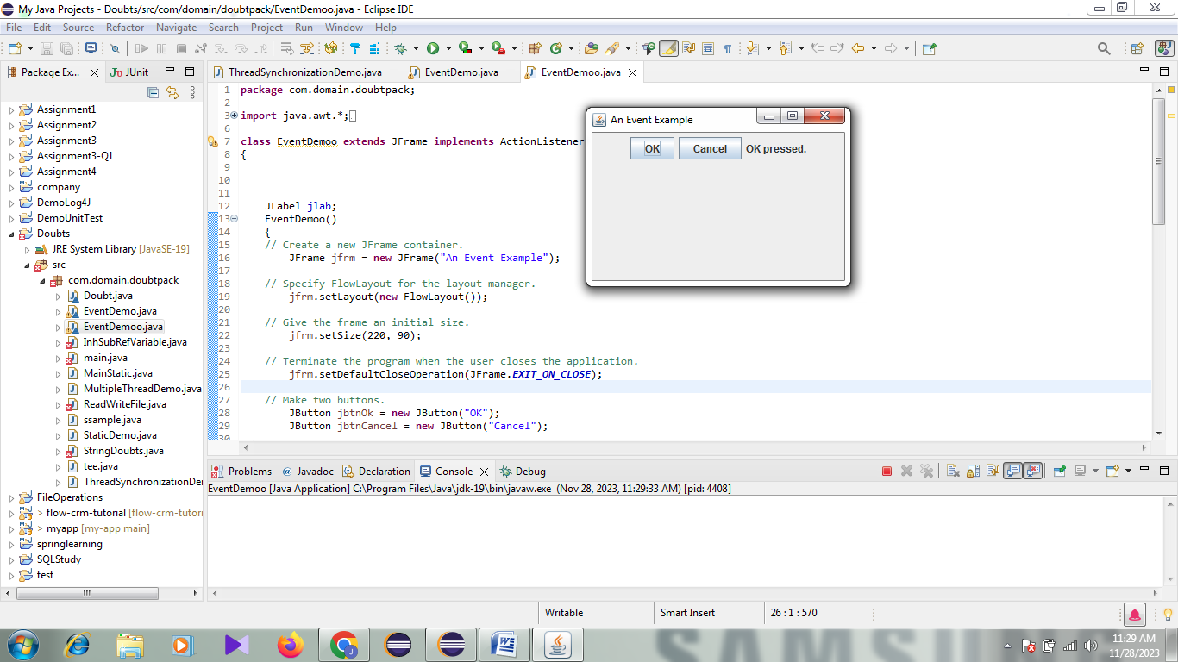 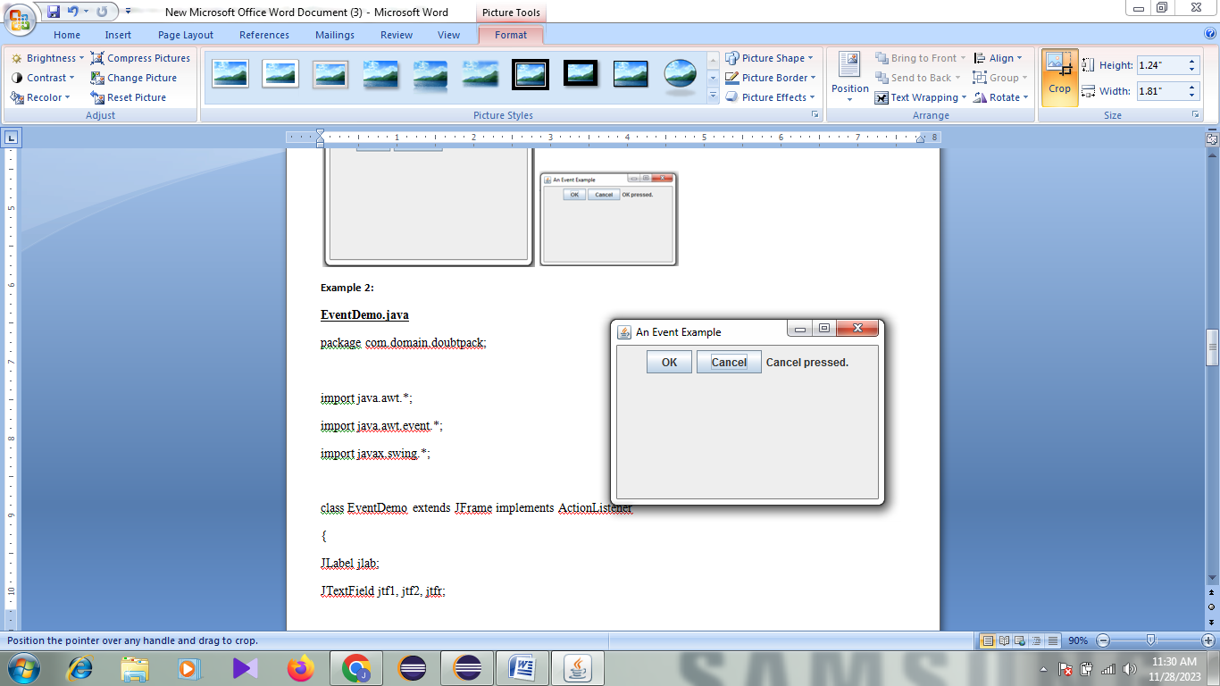

**Example 2:**

**EventDemo.java**

package com.domain.doubtpack;

import java.awt.*;

import java.awt.event.*;

import javax.swing.*;

class EventDemo implements ActionListener

{

JLabel jlab;

JTextField jtf1, jtf2, jtfr;

double a=0,b=0,r=0;

EventDemo()

{

// Create a new JFrame container.

JFrame jfrm = new JFrame("Calculator");

// Specify FlowLayout for the layout manager.

jfrm.setLayout(new FlowLayout());

// Give the frame an initial size.

jfrm.setSize(220, 90);

// Terminate the program when the user closes the application.

jfrm.setDefaultCloseOperation(JFrame.EXIT_ON_CLOSE);

// Make two buttons.

JButton jbtnplus = new JButton("+");

JButton jbtnminus = new JButton("-");

JButton jbtnmul = new JButton("*");

JButton jbtndiv = new JButton("/");

jtf1 = new JTextField(15);

jtf2 = new JTextField(15);

jtfr=new JTextField(15);

// Add action listener for plus button.

jbtnplus.addActionListener(this);

// Add action listener for minus button.

jbtnminus.addActionListener(this);

// Add action listener for mul button.

jbtnmul.addActionListener(this);

// Add action listener for div button.

jbtndiv.addActionListener(this);

// Add the buttons to the content pane.

jfrm.add(jtf1);

jfrm.add(jtf2);

jfrm.add(jtfr);

jfrm.add(jbtnplus);

jfrm.add(jbtnminus);

jfrm.add(jbtnmul);

jfrm.add(jbtndiv);

// Display the frame.

jfrm.setVisible(true);

}

public void actionPerformed(ActionEvent ae)

{

//store the name written in button that is clicked ,in variable s

String s = ae.getActionCommand();

if(s.equalsIgnoreCase("+"))

//jlab.setText("OK pressed.");

a=Double.parseDouble(jtf1.getText());

b=Double.parseDouble(jtf2.getText());

r=a+b;

jtfr.setText(""+r);

}

public static void main(String args[])

{

new EventDemo();

}

}

